Lab#7 Create dashboard with accordion using Bootstrap. Each accordion contains different bootstrap components.

TAGS USED | DESCRIPTION
<!DOCTYPE HTML> | DECLARES THE DOCUMENT AS AN HTML5 DOCUMENT.
<HTML> | ROOT ELEMENT OF THE HTML DOCUMENT.
<HEAD> | CONTAINS METADATA AND INFORMATION ABOUT THE HTML DOCUMENT.
<META> | DEFINES METADATA FOR THE HTML DOCUMENT.
<LINK> | LINKS AN EXTERNAL CSS FILE TO THE HTML DOCUMENT.
<TITLE> | SPECIFIES THE TITLE SHOWN IN THE BROWSER TAB.
<BODY> | CONTAINS ALL VISIBLE CONTENT OF THE WEBPAGE.
<HEADER> | DEFINES THE HEADER SECTION OF THE WEBPAGE.
<H1> | DEFINES THE MAIN HEADING.
<H2> | DEFINES A SECONDARY HEADING.
<NAV> | DEFINES THE NAVIGATION SECTION.
<A> | DEFINES HYPERLINKS TO DIFFERENT SECTIONS OF THE WEBPAGE.
<MAIN> | DEFINES THE MAIN CONTENT OF THE WEBPAGE.
<SECTION> | DEFINES SEPARATE SECTIONS OF CONTENT.
<H3> | DEFINES SECTION HEADINGS.
<P> | DEFINES A PARAGRAPH.
<UL> | DEFINES AN UNORDERED (BULLETED) LIST.
<OL> | DEFINES AN ORDERED (NUMBERED) LIST.
<LI> | DEFINES AN ITEM IN A LIST.
<FOOTER> | DEFINES THE FOOTER SECTION OF THE WEBPAGE.

Final Outcome:

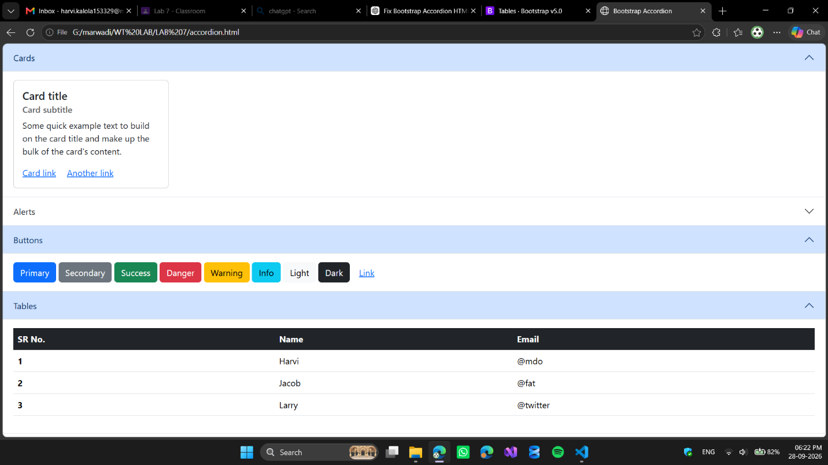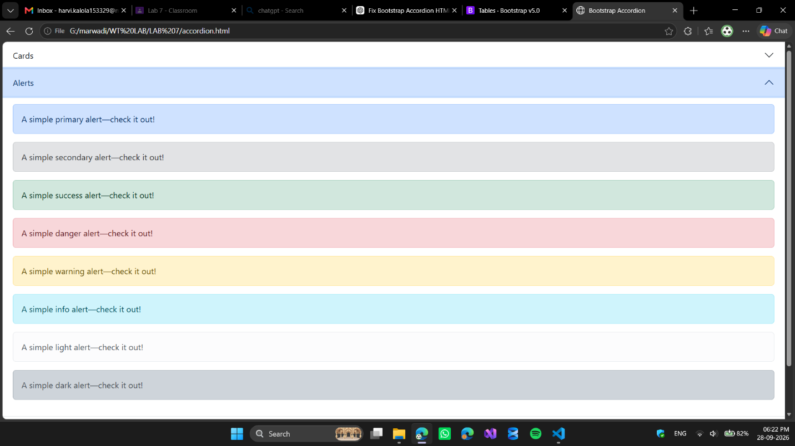

Code Snippet:

<!DOCTYPE html>
<html lang="en">

<head>
<meta charset="UTF-8">
<meta name="viewport" content="width=device-width, initial-scale=1.0">

<title>Bootstrap Accordion</title>

<!-- Bootstrap CSS -->
<link href="https://cdn.jsdelivr.net/npm/bootstrap@5.3.8/dist/css/bootstrap.min.css" rel="stylesheet"
integrity="sha384-sRIl4kxILFvY47J16cr9ZwB07vP4J8+LH7qKQnuqkuIAvNWLzeN8tE5YBujZqJLB" crossorigin="anonymous">
</head>

<body>

<!-- Bootstrap Accordion -->
<div class="accordion" id="myAccordion">

<!-- Accordion Item 1 -->
<div class="accordion-item">

<h2 class="accordion-header">
<button type="button" class="accordion-button" data-bs-toggle="collapse" data-bs-target="#p1"
aria-expanded="true" aria-controls="p1">

Cards

</button>
</h2>

<div id="p1" class="accordion-collapse collapse show" data-bs-parent="#myAccordion">

<div class="accordion-body">
<div class="card" style="width: 18rem;">
<div class="card-body">
<h5 class="card-title">Card title</h5>
<h6 class="card-subtitle mb-2 text-muted">Card subtitle</h6>
<p class="card-text">
Some quick example text to build on the card title and make up the bulk
of the card's content.
</p>
<a href="#" class="card-link">Card link</a>
<a href="#" class="card-link">Another link</a>
</div>
</div>
</div>

</div>
</div>

<!-- Accordion Item 2 -->
<div class="accordion-item">

<h2 class="accordion-header">
<button type="button" class="accordion-button collapsed" data-bs-toggle="collapse" data-bs-target="#p2"
aria-expanded="false" aria-controls="p2">

Alerts

</button>
</h2>

<div id="p2" class="accordion-collapse collapse" data-bs-parent="#myAccordion">

<div class="accordion-body">
<div class="alert alert-primary" role="alert">
A simple primary alert—check it out!
</div>
<div class="alert alert-secondary" role="alert">
A simple secondary alert—check it out!
</div>
<div class="alert alert-success" role="alert">
A simple success alert—check it out!
</div>
<div class="alert alert-danger" role="alert">
A simple danger alert—check it out!
</div>
<div class="alert alert-warning" role="alert">
A simple warning alert—check it out!
</div>
<div class="alert alert-info" role="alert">
A simple info alert—check it out!
</div>
<div class="alert alert-light" role="alert">
A simple light alert—check it out!
</div>
<div class="alert alert-dark" role="alert">
A simple dark alert—check it out!
</div>
</div>

</div>
</div>

<!-- Accordion Item 3 -->
<div class="accordion-item">

<h2 class="accordion-header">
<button type="button" class="accordion-button" data-bs-toggle="collapse" data-bs-target="#p3"
aria-expanded="true" aria-controls="p3">

Buttons

</button>
</h2>

<div id="p3" class="accordion-collapse collapse show" data-bs-parent="#myAccordion">

<div class="accordion-body">
<button type="button" class="btn btn-primary">Primary</button>
<button type="button" class="btn btn-secondary">Secondary</button>
<button type="button" class="btn btn-success">Success</button>
<button type="button" class="btn btn-danger">Danger</button>
<button type="button" class="btn btn-warning">Warning</button>
<button type="button" class="btn btn-info">Info</button>
<button type="button" class="btn btn-light">Light</button>
<button type="button" class="btn btn-dark">Dark</button>
<button type="button" class="btn btn-link">Link</button>
</div>

</div>
</div>

<!-- Accordion Item 4 -->
<div class="accordion-item">

<h2 class="accordion-header">
<button type="button" class="accordion-button" data-bs-toggle="collapse" data-bs-target="#p4"
aria-expanded="true" aria-controls="p4">

Tables

</button>
</h2>

<div id="p4" class="accordion-collapse collapse show" data-bs-parent="#myAccordion">

<div class="accordion-body">
<table class="table">
<thead class="table-dark">
<tr>
<th scope="col">SR No.</th>
<th scope="col">Name</th>
<th scope="col">Email</th>
</tr>
</thead>
<tbody>
<tr>
<th scope="row">1</th>
<td>Harvi</td>
<td>@mdo</td>
</tr>
<tr>
<th scope="row">2</th>
<td>Jacob</td>
<td>@fat</td>
</tr>
<tr>
<th scope="row">3</th>
<td>Larry</td>
<td>@twitter</td>
</tr>
</tbody>
</table>
</div>

</div>
</div>

</div>

<!-- Bootstrap JavaScript -->
<script src="https://cdn.jsdelivr.net/npm/bootstrap@5.3.8/dist/js/bootstrap.bundle.min.js"
integrity="sha384-FKyoEForCGlyvwx9Hj09JcYn3nv7wiPVlz7YYwJrWVcXK/BmnVDxM+D2scQbITxI"
crossorigin="anonymous"></script>

</body>

</html>

